

**COMP1640 – Enterprise Web Software Development**

**(Group Reports)**

**Student Team Member’s Name:**

Bok Chou Zheng

Khiew Chia Chuan

Ho Seow Woon

Lee You Chen

**Table of Content**

|  |  |  |
| --- | --- | --- |
| **No.** | **Task** | **Page** |
|  | Database | 3, 4 |
|  | Site Design | 5 |
|  | Functionality | 6, 7 |
|  | Testing | 8 |
|  | Agile methods | 8 |

1. **Database**

**Data Types for database information**

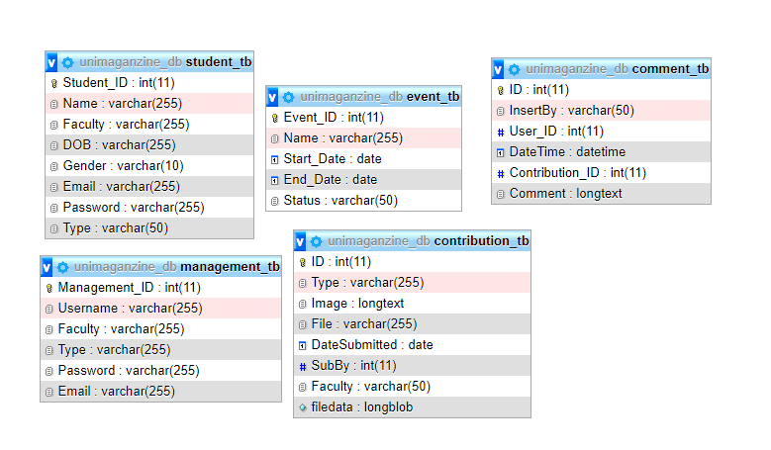

**management_tb**

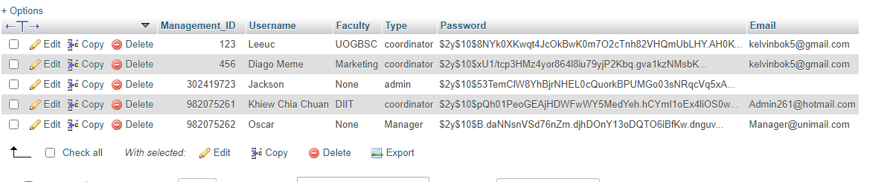

In this management table basically will be manage all the information of workers. Basically, the admin will be managing all the faculty coordinator includes create new coordinator. Admin also able to make changes of the workers via this database. Manager will be the boss of all faculty and each faculty of coordinator will be managing all their faculty’s students.

**student_tb**

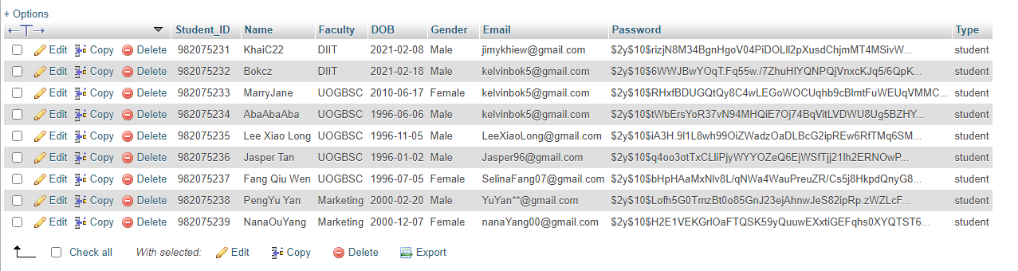

In this student table will be storing all the student’s login account and information. Student able to login into Index page using their own account. Then, they are able to submit image and file for the annual university magazine if there is any event need to be proposed.

**event_tb**

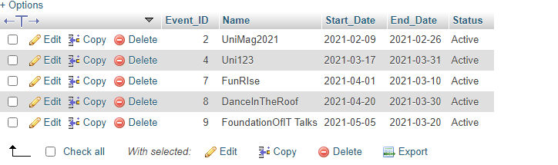

For this event table will be created by admin. Admin will based on the event to create the entry start date and end date for student to submit their articles to the magazines.

**contribution_tb**

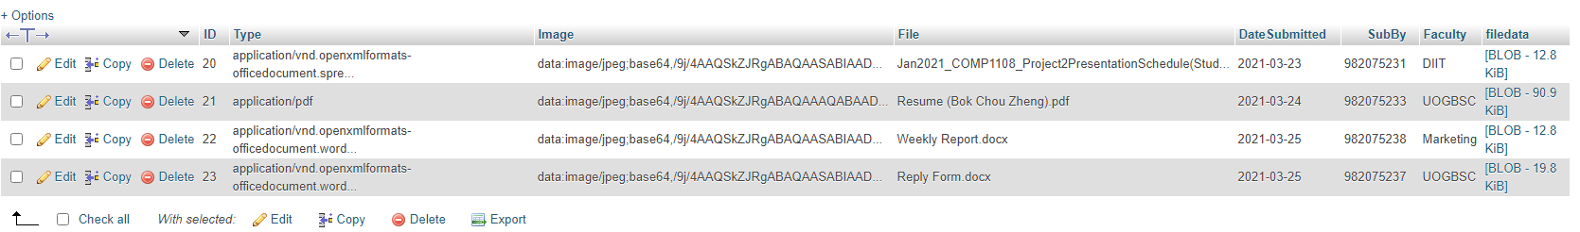

In this contribution table basically will be storing all the image and file that student has submitted. The student also able to update their file until the closed file date.

**comment_tb**

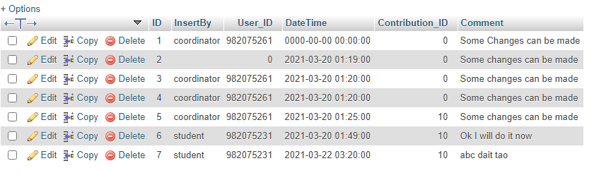

In this comment table will be storing all the comment between coordinator and students. Coordinator can give feedback or comment to their faculty’s students if there are some changes need to be performed for the articles.

**ERD Diagram**

The design of ERD Diagram will be inside GitHub Group-Component/Database folder.

1. **Site Design**

All the site Design will be appendix to the localhost of our system. Besides that, we also provide code in GitHub Group-Component/Code folder. We are using HTML, CSS and some Bootstrap to design our user interface. Then, we use PHP as our main programming language to develop this system. We also using some JS code while create some function.

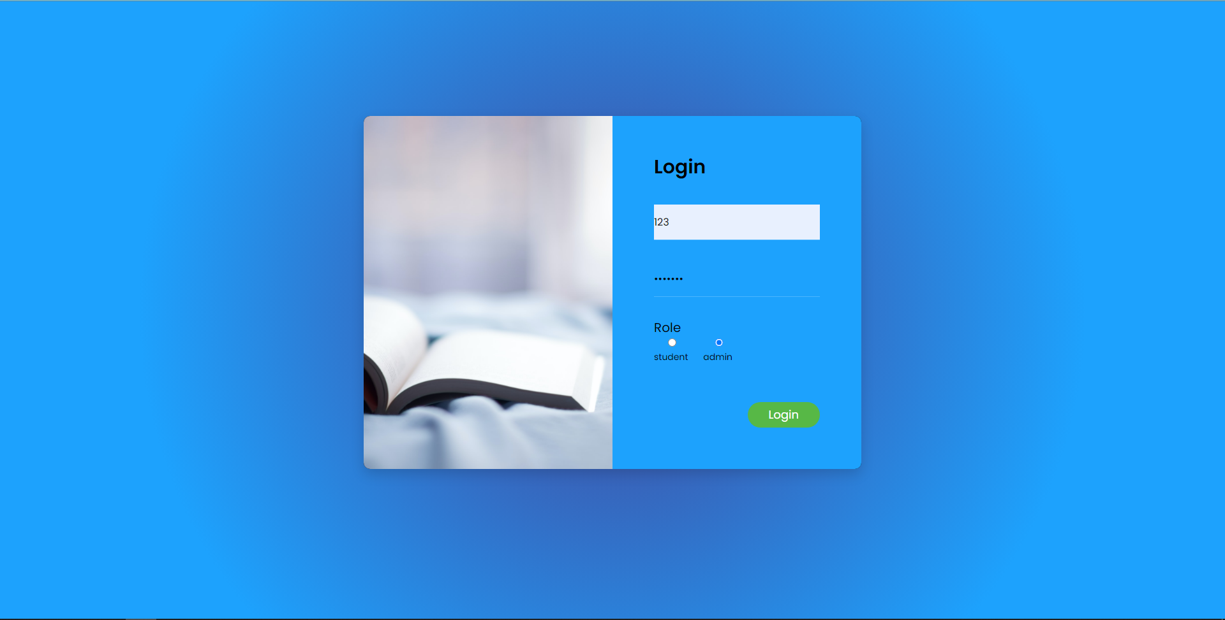

Figure 1.0 Login Page (Desktop view)

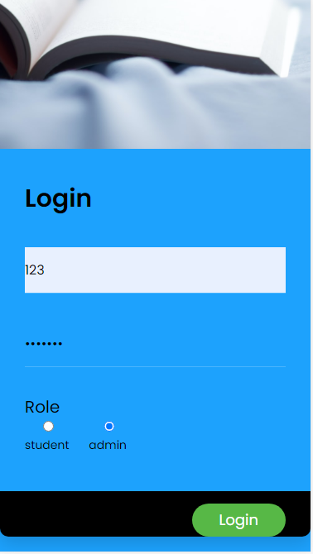 Figure 1.1 Login Page (Mobile View)

1. **Functionality**

In this functionality I will basically get some of the function from our system to explain. Figure 2.0 is the student submission form page that can able students to submit their articles. In figure 2.1 will be the code that use to functioning the submission. After the student has made submission, an email will send out to their own faculty’s coordinator to remind them as their articles has submitted. Figure 2.2 will be the email notification that has been send to coordinator for reminder. Figure 2.3 will be the sending email code using php mailer. Besides that, there will be UML class diagram that has been design for easier us while creating the database in GitHub Group-Component/Functionality Folder.

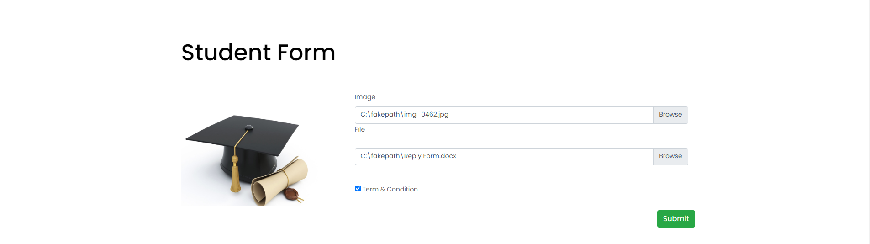

Figure 2.0 Student Submission Form Page

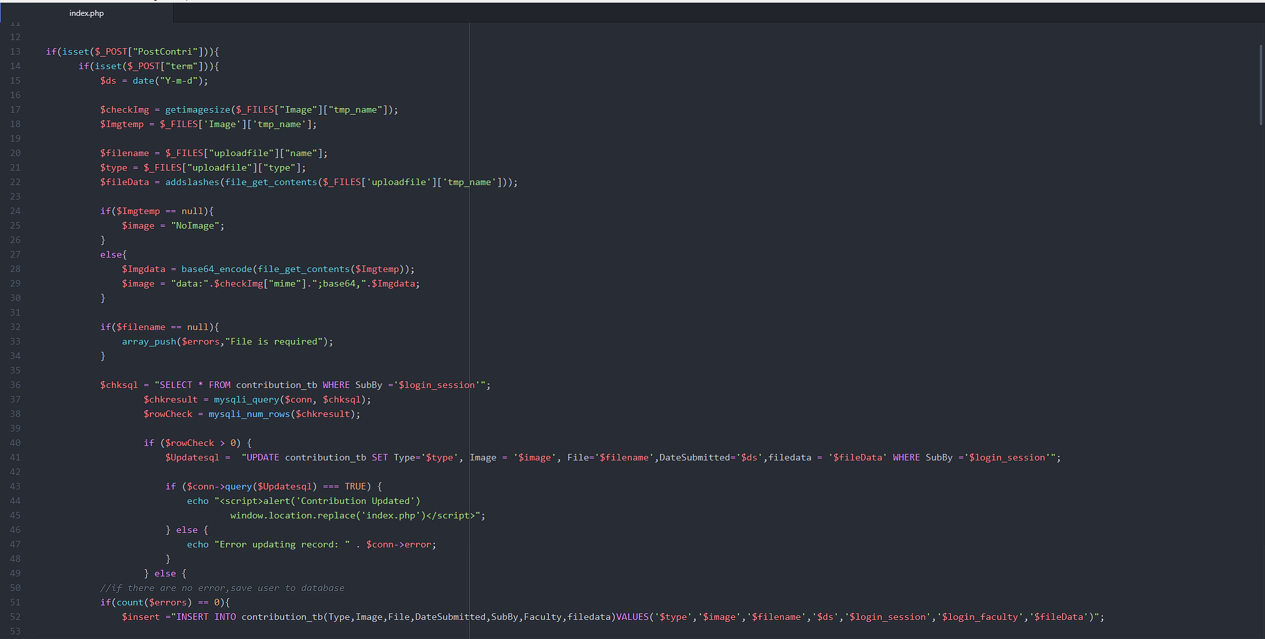

Figure 2.1 Code for Student Submission Form Page

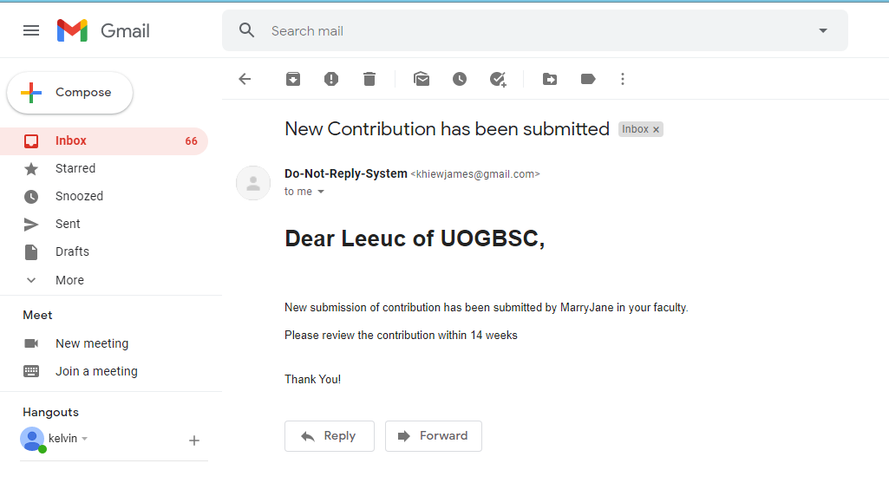

Figure 2.2 Email Notification

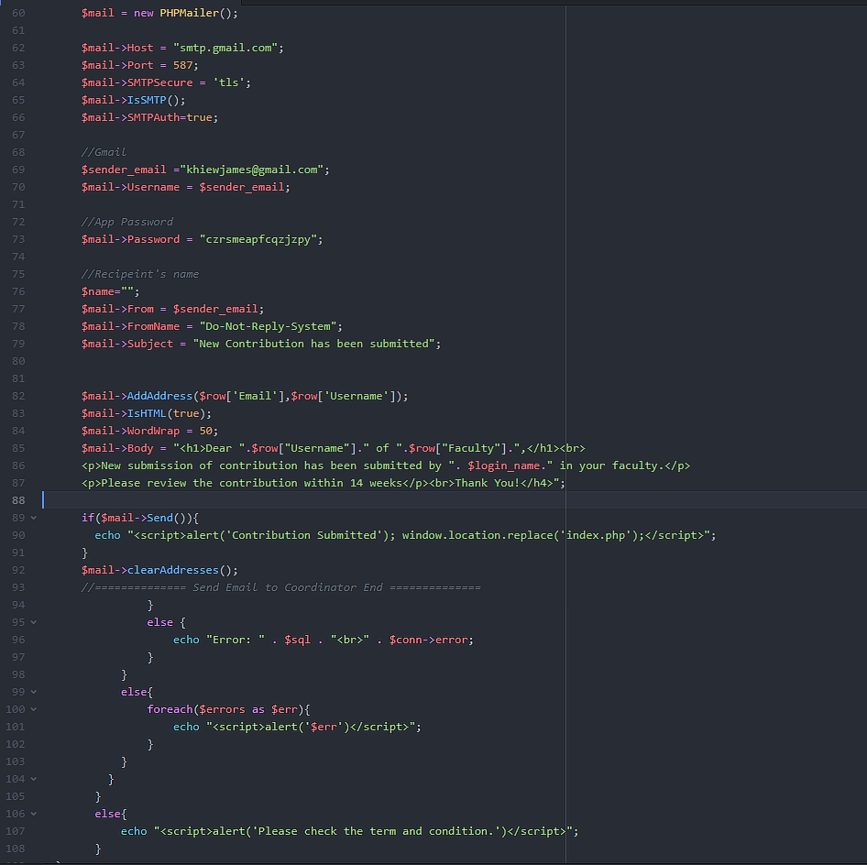

Figure 2.3 Code for Email Notification

1. **Testing**

There is some testing that our team has been done after develop the system. In the process of testing, we have found out some problem of the function. Then we will set the test as failed and recode the function. After the problem has solve, the test log will re-enter the task again which is success in the test log. Before that, we have created a test plan first to decided what we going to test for all the function. Next, we have using the test log to test out all the functionality either is workable or not. There is the folder for each test plan and test log in GitHub Group-Component/Testing folder.

1. **Agile Methods**

In this agile method which will have provide the user story and its product backlog for the system. At first, we have created product backlog for us to know the user story for the coursework that what we should create for the system. After list out the product item and its user story, we have started to develop our system based on it. Next, every week we will have a meeting on our progression of our system development. Then, scrum master will record all the meeting minutes in document. Besides that, we also have created a sprint backlog for every week in the meeting to estimate the development hours for each of the task. In GitHub Group-Component/Agile method folder have all the documentation like product backlog, sprint backlog and minutes of meetings.